### Abstract

OWASP ZAP (Zed Attack Proxy) is an open source penetration testing tool for finding vulnerabilities in web applications. The ZAP application’s current report capability is to generate limited types of reports for ZAP testing results in the formats such as in HTML and XML. Although these reports serve the basic purpose but they are not efficient when it comes to data manipulation and to provide support for flexible data formats such as PDF.

The proposed project shall provide the users of ZAP, a reporting module that will be integrated with the existing ZAP implementation. The module will use the existing ZAP result outputs and generate reports for the end-users to analyse the testing results in a productive way.

### Objectives:

* Installed and Configured BIRT environment to be used in Eclipse OWASP ZAP project.
* Be able to generate reports from the application using the BIRT report engine API.
* Creation of prototype reports regarding the results output of the Sessions & attacks such as: Alerts, History, Search etc.
* A new user interface for generating reports which is easy to use and provides the user with a wide range of options.
* Analysis report of the pros-and cons of using BIRT within OWASP ZAP as a reporting tool.

## Work breakdown structure with Timeline and expected results

### Introduction

The current reporting module in ZAP is capable to generate limited types of reports on the results produced by ZAP e.g., in HTML and XML formats. Although these reports serve the basic purpose but they are not efficient when it comes to data manipulation and to provide support for flexible data formats such as PDF.

The proposed project shall provide the users of ZAP, a reporting module that will be integrated with the existing ZAP implementation. The module will use the existing ZAP result outputs and generate reports for the end-users to analyse the testing results. The report structure shall be designed by using BIRT RCP Report Designer.

BIRT (The Business Intelligence and Reporting Tools) project is an open source software project that provides reporting and business intelligence capabilities for rich client and web applications.

In relation to this project, there are two main components of BIRT:

1. A report designer within the Eclipse IDE for creating BIRT Report prototypes.
2. A runtime component (BIRT Report Engine API) for generating reports that can be deployed to OWASP ZAP.

### Proposed Solution and Implementation

The proposed solution consists of the following three stages:

**1. Create a Reporting Module**

Develop a reporting module using BIRT Report Engine API. This module shall be able to generate reports within OWASP ZAP. The Report Engine API is a part of the package "org.eclipse.birt.report.engine.api". This API shall provide the most commonly used functionality for the proposed module. The module shall use the "ReportEngine" class of the API for generating reports.

**2. Design Report structure**

Several report prototypes for various ZAP result outputs shall be designed using the BIRT RCP Report Designer application. It is a standalone tool that is used to build a BIRT report design and preview a report. The prototypes, created by the tool, will be used by the proposed Reporting module to display the reports for ZAP output results.

**3. Create a Data source**

OWASP ZAP shall produce XML results which will be fed into the proposed BIRT reporting module. The reporting module shall read it as a data source to generate reports. XML output is generated by the ZAP namespace “org.parosproxy.paros.extension.report”

**System Context Diagram**

The following diagram shows the high level system context diagram within ZAP.

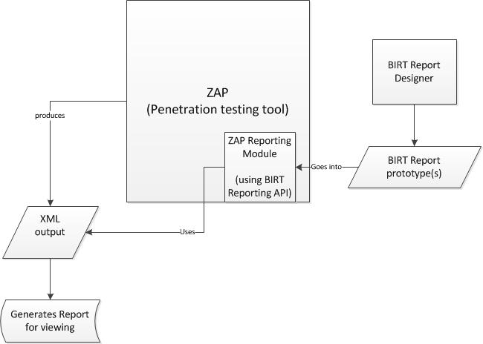

Figure: System context diagram.